# Project Summary

The project I want to complete is a web system about house renting, which contains two parts: front-end trading system and back-end man-agement system. The system can provide users with a short-term rental demand, and recommend users according to the latest sales leaderboard. Meanwhile, it can also recommend some information of housing re-sources participating in preferential activities, so that users can select according to the types of houses and other functions.Specific functions are as follows:

1. Customers can sign up

2. Customers can become admin when they publish housing infor-mation

3. Customers can bowse the rental listings

4. Customers can browse the latest release of housing information

5. Customers can browse the information of preferential rent Admin can add products

6. Customers can view their orders

7. Customers can view the details of the housing information

8. Customers can add their favorite rental information to their favor-ites

9. Customers can view favorites

10. Customers can choose how long they want to rent

11. Customers can choose to continue browsing or go to checkout

12. Customers can view the site's announcement messages

13. Admin can query by type of housing source

14. Admin can delete their own published property

15. Admin can view the listing details

16. Admin can choose to set the property as a discount

17. Admin can change the price of participating in discount listings

18. Admin can add housing information

19. Admin can add and delete membership information

20. Admin can add and remove background administrators

21. Admin can change passwords in the background

22. Admin can view all orders

23. Admin can modify queries and delete all orders

24. Admin can add relevant site information

25. Admin can choose to exit the background system

# Project Requirements

|  |  |  |
| --- | --- | --- |
| Number | Requirements/Responsibilities | Description |
| 1 | Customers can choose the corresponding housing source category according to their needs. | Some customers may need to choose the corresponding short-term rental housing source, some want to rent for a long time, some like the apartment type, some like the inns type of houses, then customers can first choose a large category into the choice |
| 2 | If the client does not know how to choose, he/she may need to know which houses are popular and highly rated by the client | The system will highly recommend the sales volume to users according to the leasing situation |
| 3 | For the housing supply providers, it is possible to expand the publicity of some housing information participating in preferential discounts to the greatest extent | For the housing source providers, they want to offer certain discounts for certain housing sources, but it is a thorny problem to improve the publicity scope of housing source information. The system can publish the houses participating in the discount on the home page in the form of announcement |
| 4 | The merchants are graded, and the good ones are recommended to users based on the ratings | For customers, it may be a headache to find the most high-quality merchants. A merchant with high trust and high evaluation may also be a very important reference for customers' choice |
| 5 | Users can query the latest release of housing information | By displaying the newly released housing information, the housing information can be accessed more efficiently by more people, so that the housing information publishers can communicate with customers online or offline in real time |
| 6 | Businesses can set and modify the information of housing sources in the background, and can choose whether to set certain housing sources as special housing sources to increase visits | For the merchants, if some houses remain unsold, it may be because of price and other factors, so they can enter the background to set it as a special house source, modify its rent, so as to get more views and increase the probability of renting |
| 7 | Administrators can add members in the background | For some businesses, there may be some long-term customers, so they can be set as members in the background, and some discounts can be offered when they communicate offline |
| 8 | The administrator can set the account in the background, add and delete the information of the administrator corresponding to the merchant. | For administrators, can be directly assigned accounts in the background, the roles assigned to the role of administrator, at the same time can log on to the front desk system, the function is mainly used in some of the dealer the relatively large size, you can allocate a few more staff to deal with the background data, and these create administrator role can access to all the merchants' background data, but they have their own account information also can exist as the role of a client, they have a common ID, this ID is the ID of the businessman |
| 9 | When the order is completed, the administrator updates the status of the order in the background, and the status of the room is updated simultaneously | The administrator can view the detailed information of the order, and change the corresponding status to be completed for the customer checked in order, then update the status of the room to be unselected at the same time, and the room can be selected by the new customer |
| 10 | Merchants can offer restaurants or snacks with local characteristics to attract customers | For some houses located in scenic areas or some areas with local characteristics, it is advisable to add local restaurants or local merchants' featured snacks to attract customers, so as to improve the influence and increase the publicity |

# UI Mockups

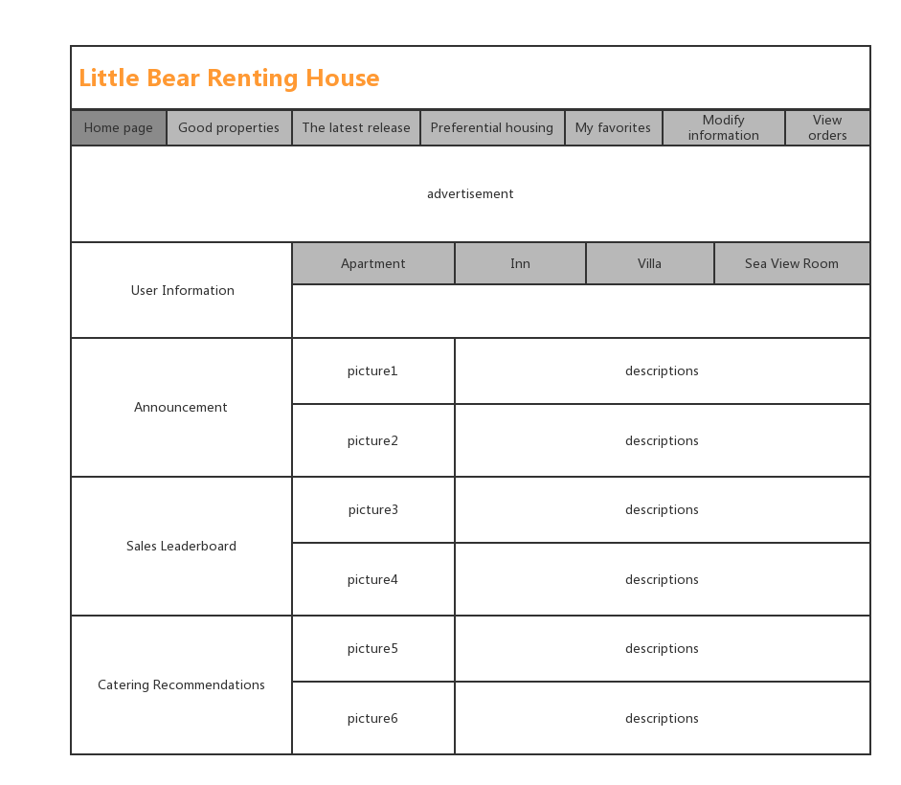

figure 1 Front Page Interface

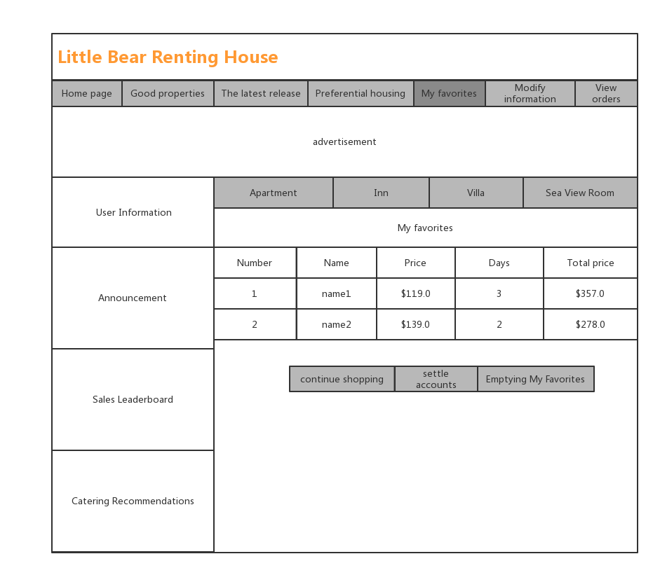

figure 2 My favorites

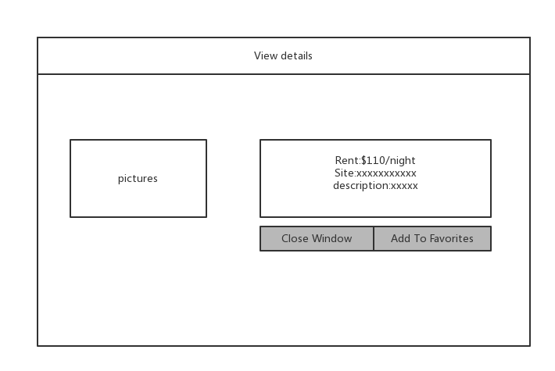

figure 3 View Details

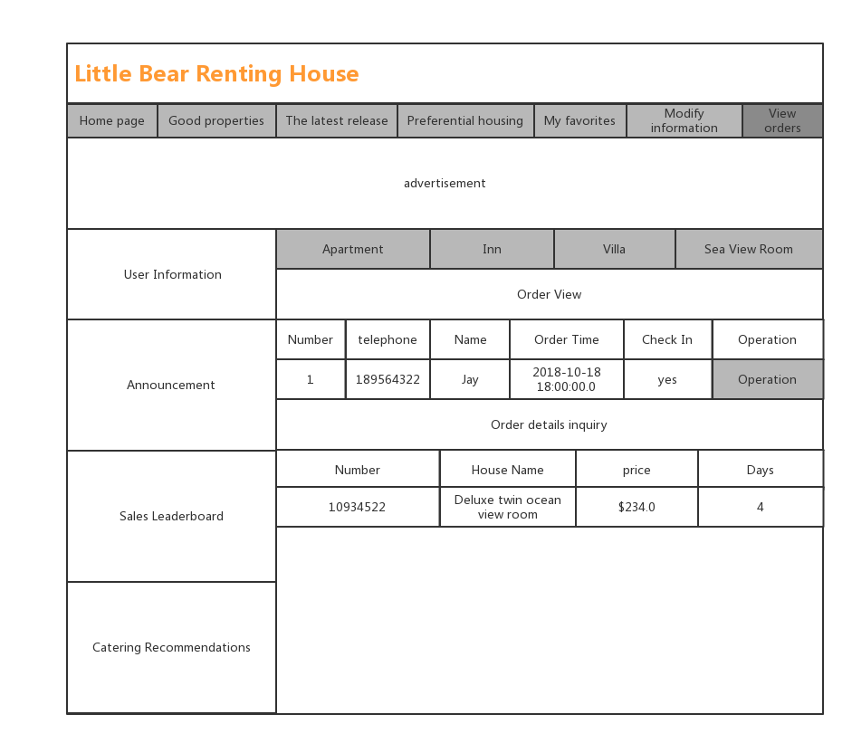

figure 4 Order Inquiry

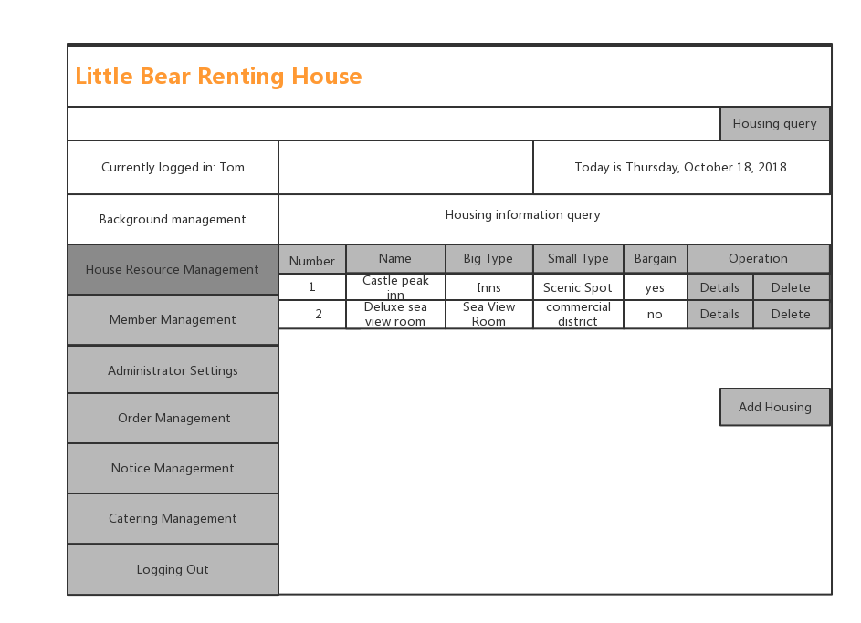

figure 5 House Resource Management

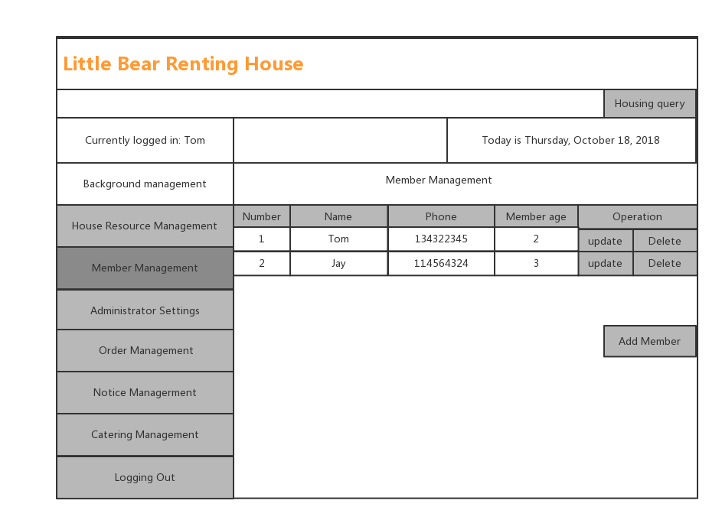

figure 6 Member Management

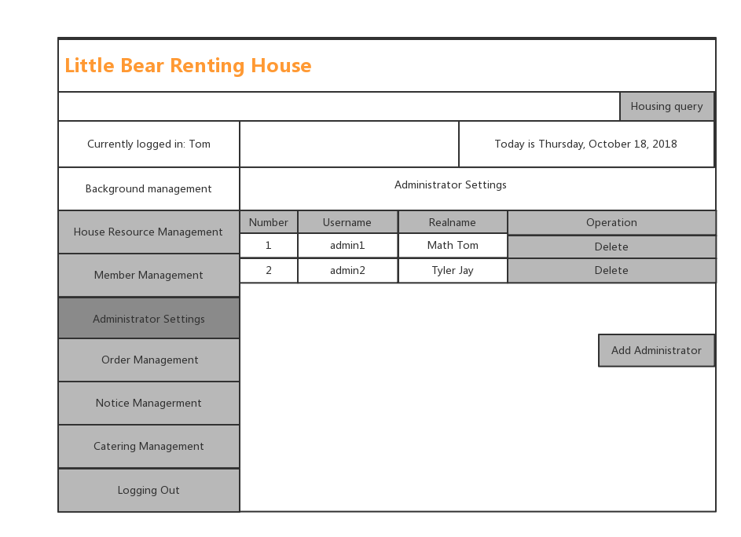

figure 7 Administrator Settings

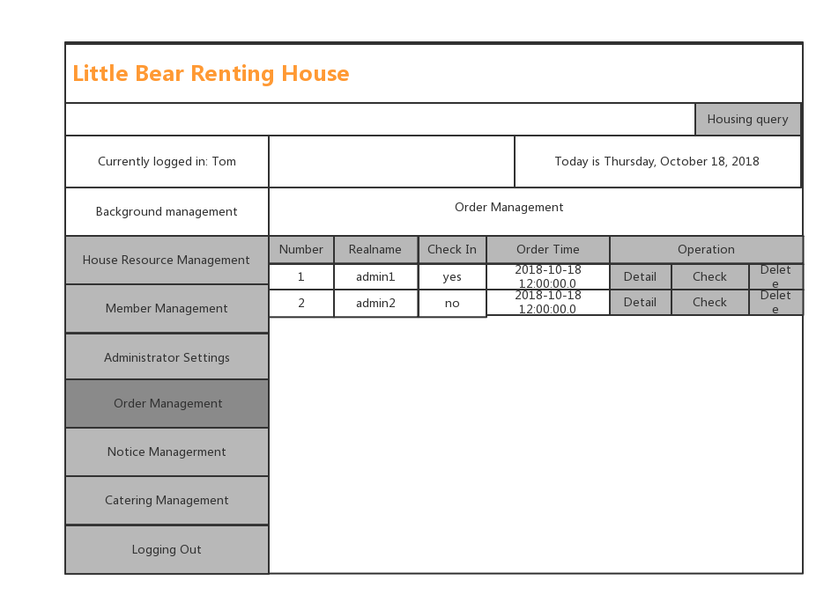

figure 8 Order Management

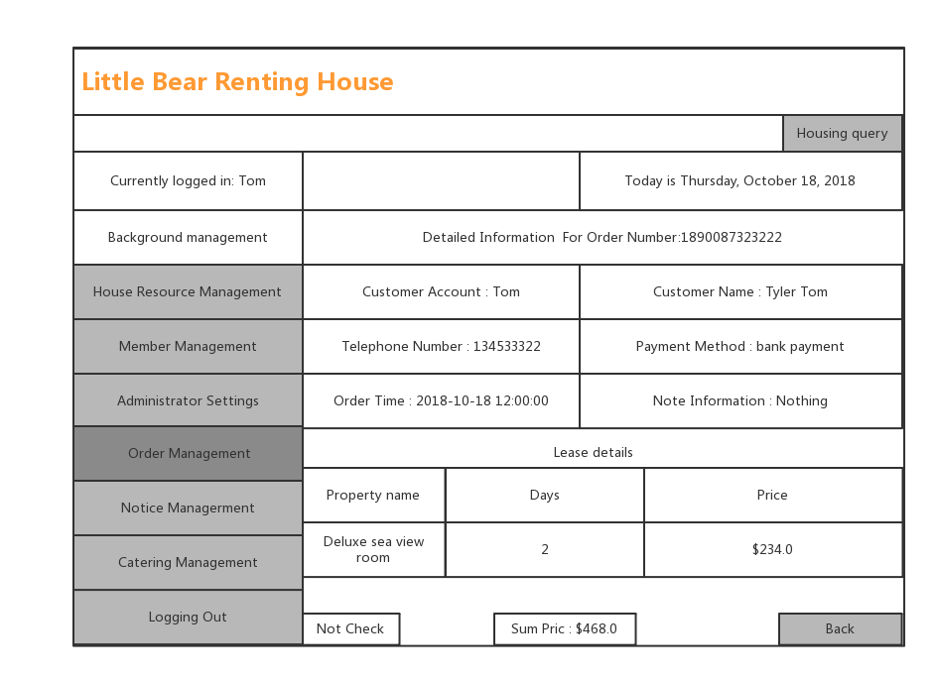

figure 9 Search Detailed Information For Some Order

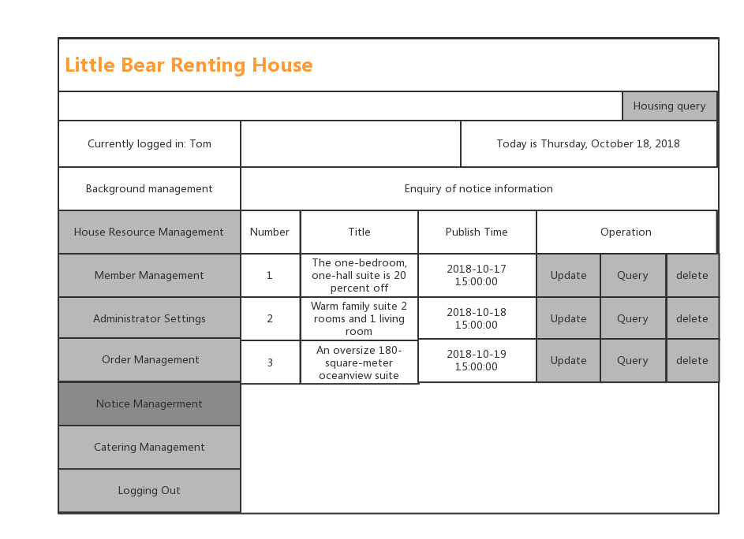

figure 10 Notice Managerment

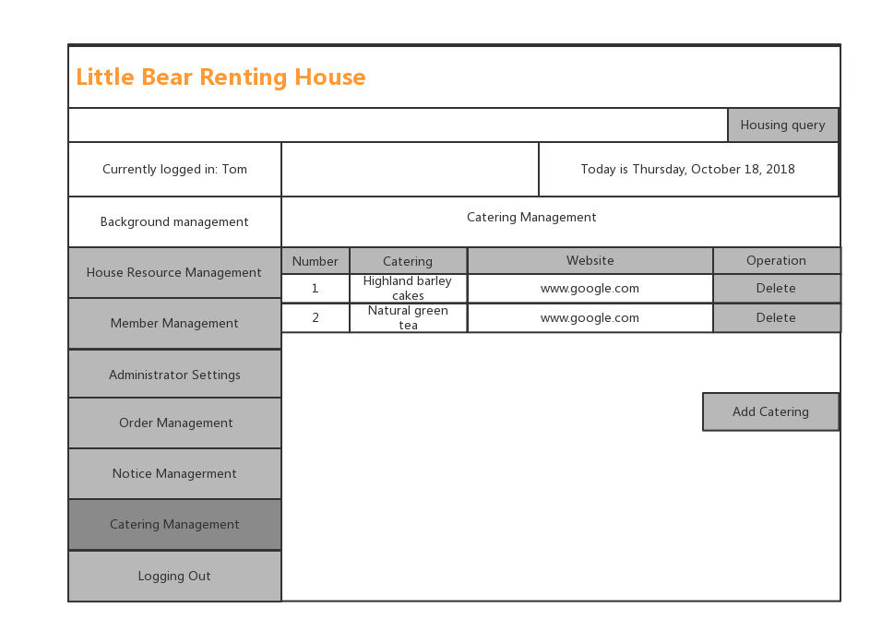

figure 11 Catering Management

# Class Diagram

